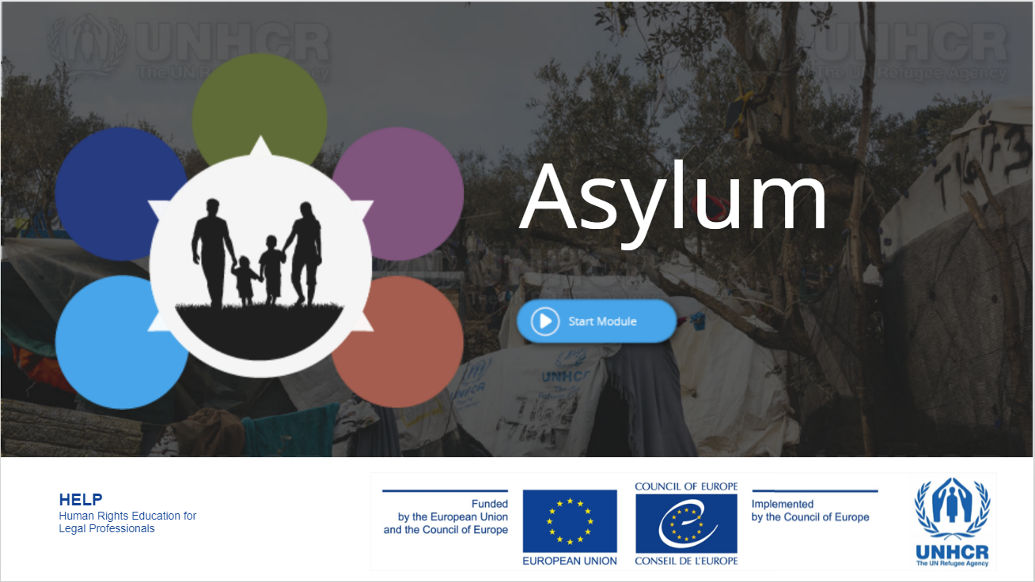  Concept paper – Agenda | HELP in the EU II Launch of the course on Asylum and Human Rights

Launch of the HELP/UNHCR course on
Asylum and Human Rights

Concept paper and Agenda

Date | 14 January 2022 (13.30 CET / 14.30 EET)
Location | Online (web-conference) Link – provided to selected participants prior to the session
Language | English (no interpretation provided)
Participation | Lawyers from Latvia, Lithuania and Poland
Registration | ONLINE REGISTRATION FORM

Background

The Council of Europe (CoE) Programme for Human Rights Education for Legal Professionals (HELP) is aimed at supporting the CoE member States in implementing the European human rights standards at the national level, focusing on the European Convention on Human Rights (ECHR), other key CoE instruments, and since 2015, EU law. This is done by raising the capacities of legal professionals to apply those instruments in their daily work.
The objective of HELP is to provide high quality education on human rights to judges, lawyers and prosecutors throughout Europe. Law enforcement authorities such as police and prison staff are also targeted by HELP. Thanks to HELP courses, legal professionals can better protect human rights on a national level and keep up to date with the ever-evolving standards and case law of the European Court of Human Rights (ECtHR). HELP courses specifically designed for EU countries increasingly incorporate relevant EU laws.

HELP is:
1. the only pan-European Network of national training institutions for judges, prosecutors and lawyers in the 47 CoE Member States.
2. an e-learning platform with free on-line courses on human rights.
3. a human rights training methodology for legal professionals.

The HELP in the EU II Project
The joint EU-CoE project ‘European Programme for Human Rights Education for Legal Professionals in the European Union’ (HELP in the EU II) is funded by the EU and implemented by the CoE from 1 September 2019 to 28 February 2022. Its overall objective is to enhance EU justice professionals’ capacities to effectively and coherently apply European fundamental rights standards at the national level through training, mainly referring to the Council of Europe instruments (the European Convention on Human Rights (ECHR), the (revised) European Social Charter (ESC) etc.) and EU framework (EU Charter on Fundamental Rights, EU Law). It also aims to strengthen the HELP Network in the EU, as well as the capacity of the Network members to effectively implement the HELP methodology and courses and contribute to increasing mutual trust and exchanges between EU practitioners.
The HELP/UNHCR course on Asylum and Human Rights

The right to asylum may not be enshrined within the European Convention on Human Rights (the ECHR). However, the ECHR applies to any asylum seeker and refugee under the jurisdiction of a High Contracting State.

This course covers in an interactive manner the aspects which are particularly relevant for asylum-seekers and refugees: it provides an overview of the main international standards, the relevant complaint mechanisms and the key aspects related to redress. It further explores the topics of non-refoulement, the right to life and the prohibition of ill-treatment; detention and reception; the right to family life; as well as effective remedies. The aim of the course is to prevent violations from happening and to support legal professionals working with asylum seekers and refugees to mainstream European human rights standards into their daily work and the national legal order.
The course was developed in 2017 and updated in 2020.

The online launch
The launch event will be held online, by web conference. Its main goal is to introduce participants to the HELP platform and the course pages on which each national group will follow the course with the assistance of a national tutor. Selected participants will receive from the HELP Secretariat a link allowing them to access the web-conference, based on which they can follow the event on their computer or mobile devices (tablet/smartphone).

The course preparation and implementation
Before the online launch event, participants should create an account on the HELP e-learning platform

For creating your HELP account, please follow these steps:
- go to this link and fill in the form (it takes about 2 mins): http://help.elearning.ext.coe.int/login/signup.php
- once submitted, you will receive an activation link on the email you used for creating the account
- go to your email inbox and click on the link to activate your account.

During the launch event, the participants will be registered on their course page, prepared in advance by their national tutors. Over the following 1.5 months and based on the planning set by the tutor, the participants will go through the online course, complemented by the course adaptation prepared by the tutor.
The participants who have successfully completed the course and passed the evaluation set by the tutors will receive certificates issued by the HELP Programme of the Council of Europe.

Registration
Interested participants should:
- be available to attend the launch event (join the web-conference via the link provided by the HELP Secretariat before the event)
- undertake to follow and complete the online tutored course in the following 1.5 months (approx. 1-2 hours of work per week)
- register for the event by 11 January 2022 through the ONLINE REGISTRATION FORM
- have a laptop/tablet/smartphone available for accessing the launch event via a link provided by the HELP Secretariat.

Further information
For any information, do not hesitate to contact the project team:
Content related issues, speakers, agenda: Ana-Maria Telbis – Project Coordinator (ana-maria.telbis@coe.int)
Organisational and administrative issues: Konstantinos Vratsidas – Project Assistant (konstantinos.vratsidas@coe.int)

Agenda – 14 January 2022

 | Online registration of participants
13.30 – 13.45 CET (Strasbourg/Warsaw)  14.30 – 14.45 EET (Tallinn/Vilnius) | Welcome address
13.45 – 14.15 CET (Strasbourg/Warsaw)  14.45 – 15.15 EET (Tallinn/Vilnius) | Asylum – challenges and perspectives  Delphine Leneutre, UNHCR Office in Strasbourg / UNHCR Poland / Geneva
14.15 – 14.40 CET (Strasbourg/Warsaw)  15.15 – 15.40 EET (Tallinn/Vilnius) | Rule 39 Requests – overview of the procedure  Speaker, ECtHR Registry / Daria Sartori, former ECtHR lawyer and HELP course tutor
14.40 – 15.20 CET (Strasbourg/Warsaw)  15.40 – 16.20 EET (Tallinn/Vilnius) | Presentation of the HELP Programme and the ‘HELP in the EU II’ Project  Overview of the online course  Presentation of the HELP platform and walk through  Ana-Maria Telbis, HELP EU II Project Coordinator, HELP Programme, Council of Europe
15.20 – 15.30 (Strasbourg/Warsaw)  16.20 – 16.30 (Tallinn/Vilnius) | Break
15.30 – 16.30 CET (Strasbourg/Warsaw)  16.30 – 17.30 EET (Tallinn/Vilnius) | The implementation of the course: tour de table and sharing of expectations, presentation of the course page, planning, evaluation  Daria Sartori, HELP course tutor  Q/A session, conclusions and closure

For more information on HELP please visit HELP’s website: www.coe.int/help
For more information about the HELP in the EU project, please go to https://www.coe.int/en/web/help/help-in-the-eu

