BAR EUROPEAN GROUP ANNUAL CONFERENCE
26TH - 27TH MAY 2019 – GDANSK, POLAND

Dear Members
The 2019 BEG Annual Conference will take place in Gdansk, Poland (formerly the free city of Danzig). Now known as ‘the City of Freedom’, it is the birthplace of Fahrenheit, Schopenhauer and Donald Tusk. https://wikitravel.org/en/Gdańsk

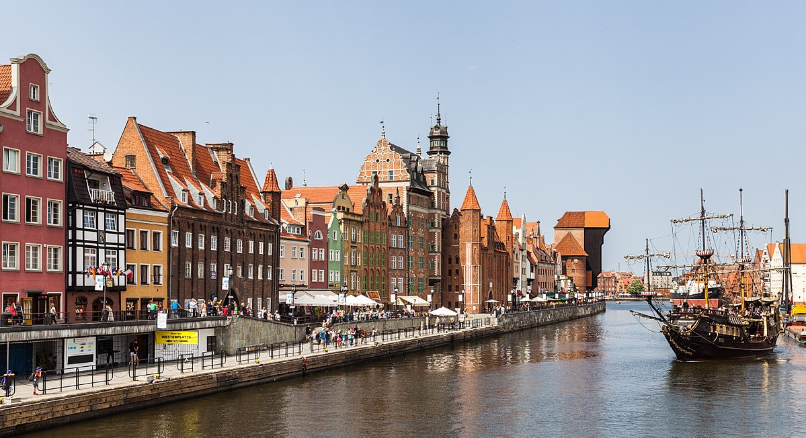

We write now to give you advance notice of the conference, in the hope that you will be encouraged to make your travel and accommodation arrangements early.
The conference will take place on the late May bank holiday weekend, Sunday 26th May to Monday morning 27th May 2019.
The topic is The EU and the UK: solidarity - past, present and future? The conference will look at how the EU (and BEG) has evolved over the years, current issues in EU law for practitioners and what the future may hold for us all (professionally at least) in the light of the state of affairs on Brexit. The schedule is subject to change.
As usual, there will be a magnificent conference dinner, an accompanying persons’ programme, and an optional tour for delegates and accompanying persons on the Monday afternoon.
Full details of the conference programme and accompanying persons’ programme will be circulated soon.

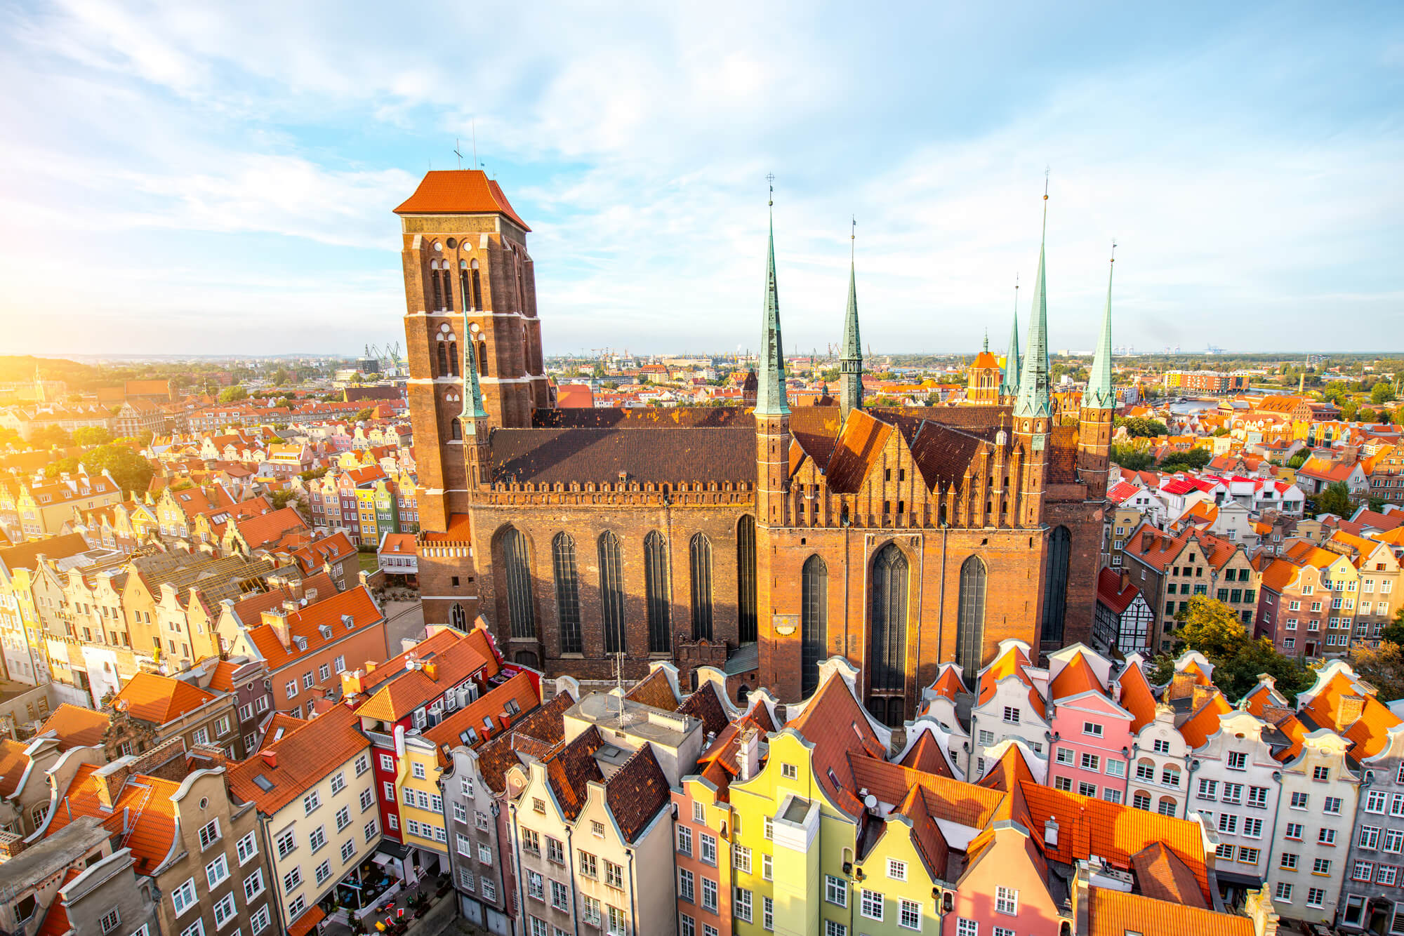

The conference venue and hotel is the Almond Hotel, Gdansk, a former chocolate and marzipan factory, now with a full conference facility, spa and pool.

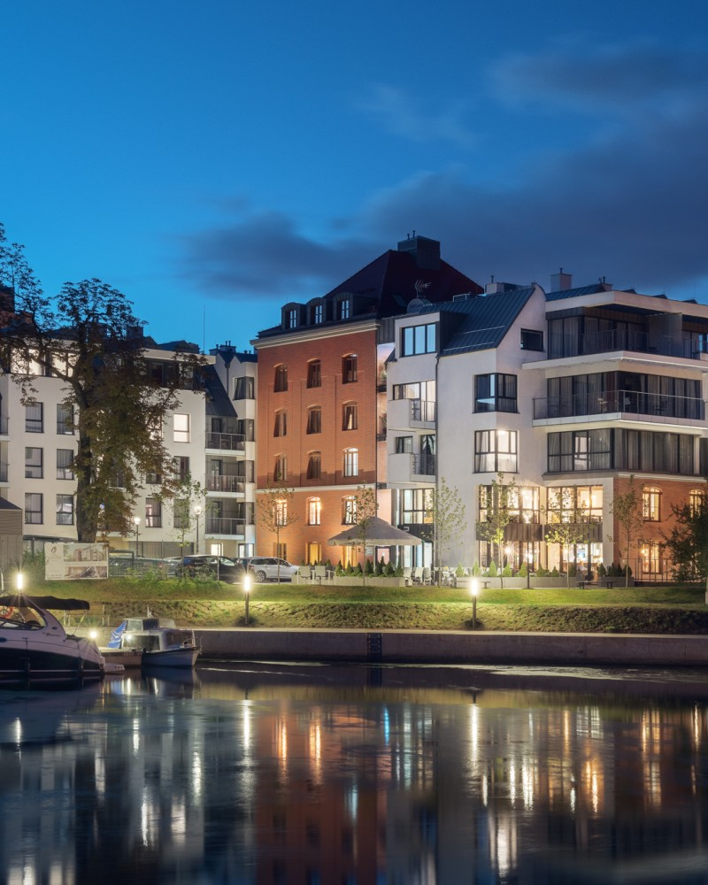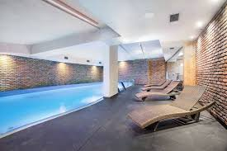

Special conference rates have been negotiated from approximately £75 for a single room or £85 for a double room. The Bar European Group has reserved 42 rooms at the Almond Hotel which can be booked on a first come first served basis. Bookings made after 1 March 2019 are likely to be dependent on availability. In order to book your room, please do so by telephone: +48 58 351 90 00 or email: rezerwacja@hotelalmond.pl stating what type of room you would like, the duration and any special requests.

There are a number of other hotels in the vicinity at a wide range of price points, including:
- The Hilton Gdansk:
www3.hilton.com/en/hotels/poland/hilton-gdansk-GDNHGHI/index.html
- The Radisson Blu Gdansk: https://www.radissonblu.com/pl/hotel-gdansk
- Hotel Gdansk Boutique: www.hotelgdansk.com.pl
- The Craft Beer Central Hotel: http://centralhotelgdansk.pl/pl
- The Puro Hotel, Gdansk: https://purohotel.pl/en/gdansk

For those planning to stay on longer, hotels are also available at the nearby beach resorts of Sopot or Gdynia, including:

- Sofitel Grand, Sopot: https://sofitel.accorhotels.com/gb/hotel-3419-sofitel-grand-sopot/index.shtml
- Marriot Sopot Resort & Spa: https://www.marriott.co.uk/hotels/travel/gdnmc-sopot-marriott-resort-and-spa/

The nearest airport is Gdansk, Poland. Direct flights are offered by Ryanair and Wizz Air. Other airlines also offer routings with one stop, including Lot.

We encourage you to book early to get the best rates. Depending on numbers, we hope to lay on coach transfers to and from the airport to the hotel at convenient times.

BEG Scholarships
The Bar European Group offers a number of fully paid scholarships (usually a minimum of six) for students and pupils wishing to come to the Gdansk conference. The scholarships are funded by several Chambers whose members practise EU law. As ever we are extremely grateful for their continued support.
Applicants must be current BPTC students or pupils with an interest in EU Law, or past BPTC students who have been accepted for pupillage beginning in 2019. The scholarships are usually awarded to candidates in whose future practice EU law is likely to play a prominent role. Scholars will have travel, accommodation and conference fees paid for them. In return they will also publish a conference report in The European Advocate and join BEG.
Applications should be sent by email to Victoria Wakefield at victoria.wakefield@brickcourt.co.uk marked 'BEG scholarship', with a CV (no more than 1 page of A4) together with a short note setting out why the applicant is suitable for this award. Please note the closing date of 31st January 2019.
We very much hope you will be able to join us for another enjoyable BEG conference.
With best wishes.

Kieron Beal QC
BEG Chairman

